2024
Lent and Easter Schedule

Day of Reconciliation and Mercy for Lent
Wednesdays: February 28th and March 20th
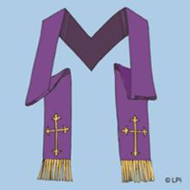
Eucharistic Adoration 10 am until 7:30 p.m.
Confessions 10 a.m. until Noon Confessions 2 p.m. until 4 p.m.
Confessions 6 p.m. until 7:30 p.m.
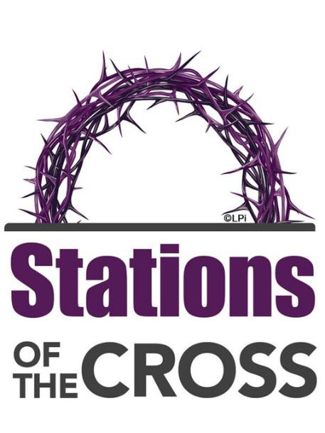
Friday Mornings after the 9:00 a.m. Mass at IHM Friday afternoons at St. Thomas More at 3:00 p.m.

And

Friday evenings at Immaculate Heart of Mary at 6:30 p.m.
Following a 6 p.m. Mass
(beginning February 23rd)
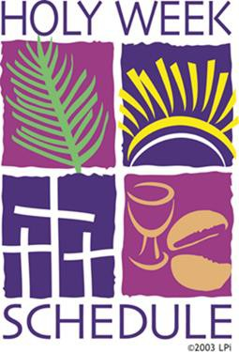

PALM SUNDAY
March 24

Saturday 4:00 p.m.

Sunday
8 a.m., 10 a.m. and Noon
HOLY THURSDAY
March 28

Morning Prayer 9:00 a.m.

Mass of the Lord’s Supper 7:30 p.m. Eucharistic Adoration until 11 p.m.
In the school gym

GOOD FRIDAY
March 29

Morning Prayer 9:00 a.m.

Liturgy of the Passion and Death 7:30 p.m.
HOLY SATURDAY
March 30

Blessing of Easter Food 11 a.m.
Easter Vigil - 7:30 p.m.

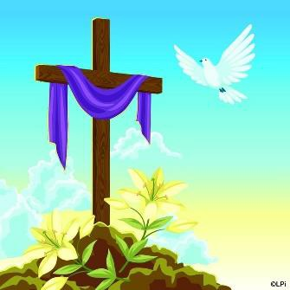
EASTER SUNDAY

March 31

Mass will be celebrated at 8 a.m., 10 a.m. and Noon.

Please join us!

